**Процессор:**

AMD Ryzen 5 5600H with Radeon Graphics, 3301 МГц,   
ядер: 6, логических процессоров: 12

**Память:** 16,0 ГБ (доступно: 15,4 ГБ)

**Задание 9**

**Предподготовка.**

*Вариант 1.*

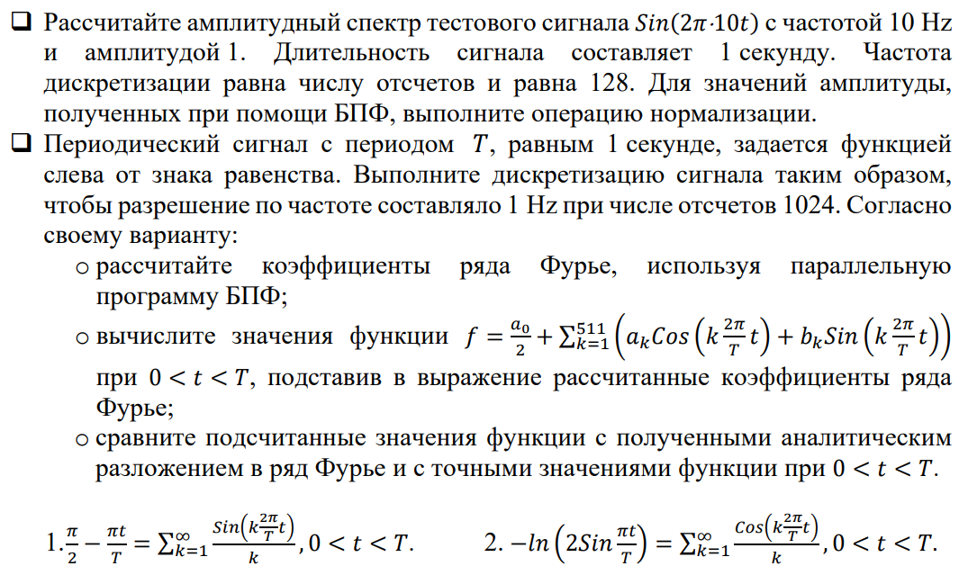

**Код предподговки:**

void Pretreatment() {

int count = 128;

double count_d = 128.0;

double eps = 1e-6;

complex<double>* inputSignal = new complex<double>[count];

complex<double>* outputSignal = new complex<double>[count];

double t;

for (int i = 0; i < count; i++) {

t = i / count_d;

inputSignal[i] = complex<double>(sin(2.0 * PI * 10 * t), 0);

}

int ampl;

ParallelFFT(inputSignal, outputSignal, count);

cout << "Pretreatment result:" << endl;

for (int i = 0; i < count; i++) {

if (abs(outputSignal[i].real()) > eps || abs(outputSignal[i].imag()) > eps) {

ampl = i;

cout << i << " " << outputSignal[i] << endl;

}

}

double norm = sqrt(outputSignal[10].imag() * outputSignal[10].imag() +

outputSignal[10].real() * outputSignal[10].real());

norm /= count / 2;

if (abs(norm - 1) < eps) {

cout << "OK" << endl;

}

else {

cout << "ERROR" << endl;

}

}

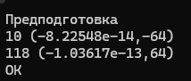

**Вариант 1:**

double f(complex<double>* signal, int size, double t) {

//вычисляем значение функции

double res = signal[0].real() / 2.0;

for (int i = 1; i < size / 2; i++) {

res += signal[i].real() * cos(i * 2.0 * PI * t / T)

- signal[i].imag() * sin(i * 2.0 * PI * t / T);

}

return res;

}

double StandardSum(double t) {

double eps = 1e-9;

double res = 0;

double s = 0;

int k = 1;

do {

s = sin(k * 2.0 * PI * t / T) / k;

res += s;

k++;

} while (fabs(s) > eps);

return res;

}

void var_1() {

int count = 1024;

complex<double>* inputSignal = new complex<double>[count];

complex<double>* outputSignal = new complex<double>[count];

for (int i = 1; i < count; i++) {

double t = i * 1.0 / count;

inputSignal[i] = complex<double>((PI / 2 - PI * t / T), 0);

}

//SerialFFT(inputSignal, outputSignal, count);

ParallelFFT(inputSignal, outputSignal, count);

for (int i = 0; i < count; i++) {

outputSignal[i] = outputSignal[i] / ((double)count / 2.);

}

cout << left << setw(10) << "Функция" << " "<< setw(10) << "Фурье" << " " << setw(10) << "Точное знач" << endl;

for (int i = 1; i < 64; i++) {

double t = i * T / count;

cout << setw(10) << f(outputSignal, count, t) << " "

<< setw(10) << StandardSum(t) << " " << setw(10) << (PI / 2 - PI * t / T) << endl;

}

}

int main()

{

setlocale(LC_ALL, "rus");

Pretreatment();

var_1();

}

